**SECTION 8**

**SCREENSHOTS**

**Program :**

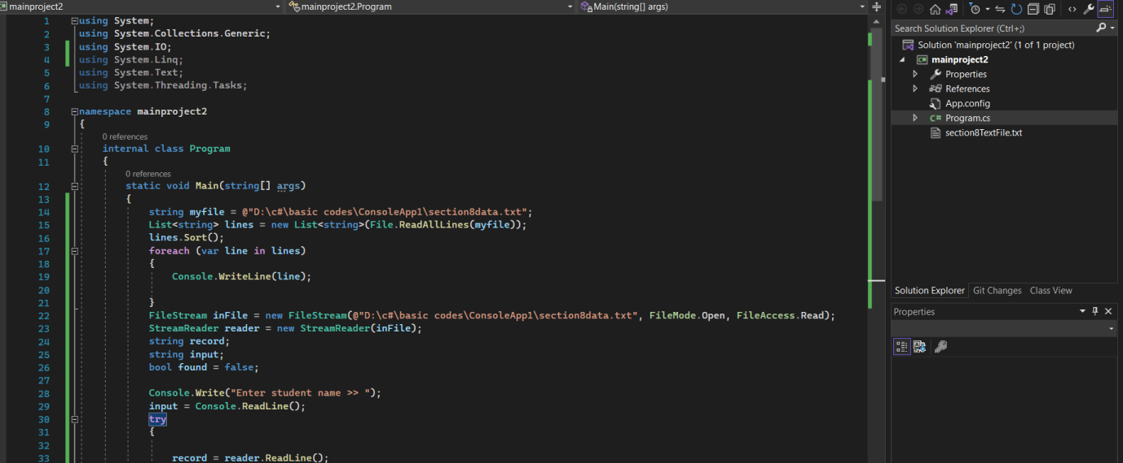

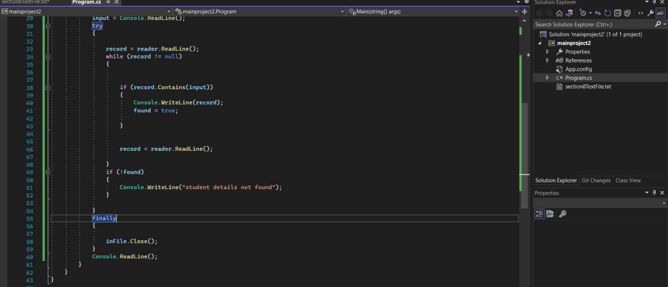

**Output :**

**Case: when name found in the list**

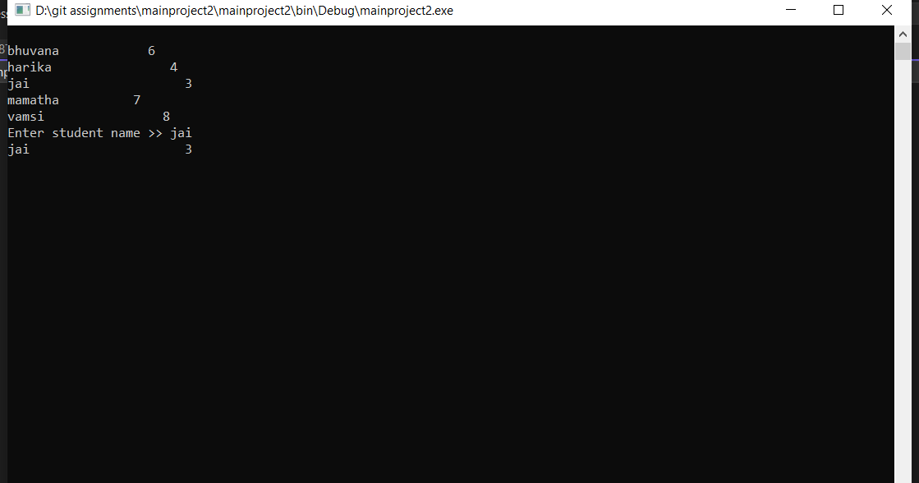

**Case2 : when name not found in list**

